***“Plant Disease Detection”***

**A Project Report Submitted to**

**Rajiv Gandhi Proudyogiki Vishwavidyalaya**



**Towards Partial Fulfillment for the Award of Bachelor of Technology in Computer Science And Engineering**

***Submitted by:***

**Abhishek Mahawadi(0827CS171005)**

**Anand Barhanpurkar(0827CS171022)**

**Anshul Dhanotiya**

**(0827CS171030)**

***Guided by:***

**Mr. Shivshankar Rajput**

**Assistant Professor, Computer Science And Engineering ,AITR, Indore**



***Acropolis Institute of Technology & Research, Indore***

**January-June 2021**

EXAMINER APPROVAL

The Project entitled ***“Plant Disease Detection”*** submitted by **Abhishek Mahawadi(0827CS171005), Anand Barhanpurkar(0827CS171022)**

**Anshul Dhanotiya(0827CS171030)** has been examined and is hereby approved towards partial fulfillment for the award of ***Bachelor of Technology degree in* Computer Science And Engineering**discipline, for which it has been submitted. It understood that by this approval the undersigned do not necessarily endorse or approve any statement made, opinion expressed or conclusion drawn therein, but approve the project only for the purpose for which it has been submitted.

#### (Internal Examiner) (ExternalExaminer)

#### Date: Date:

GUIDE RECOMMENDATION

This is to certify that the work embodied in this project entitled **“*Plant Disease Detection*”** submitted by **Abhishek Mahawadi(0827CS171005), AnandBarhanpurkar(0827CS171022),Anshul Dhanotiya(0827CS171030)**is a satisfactory account of the bonafide work done under the supervision of **Mr. Shivshankar Rajput *,*** is recommended towards partial fulfillment for the award of the Bachelor of Technology (**Computer Science And Engineering**) degree by Rajiv Gandhi Proudyogiki Vishwavidhyalaya, Bhopal.

#### (Project Guide) (ProjectCoordinator)

STUDENTS UNDERTAKING

This is to certify that project entitled ***“Plant Disease Detection”*** has been developed by us under the supervision of **Mr. Shivshankar Rajput**. The whole responsibility of work done in this project is ours. The sole intention of this work is only for practical learning and research.

We further declare that to the best of our knowledge, this report does not contain any part of any work which has been submitted for the award of any degree either in this University or in any other University / Deemed University without proper citation and if the same work found then we are liable for explanation to this.

**Acknowledgement**

We thank the almighty Lord for giving us the strength and courage to sail out through the tough and reach on shore safely.

There are number of people without whom this project work would not have been feasible. Their high academic standards and personal integrity has provided us with continuous guidance and support.

We owe a debt of sincere gratitude, deep sense of reverence and respect to our guide and mentor **Mr. Shivshankar Rajput ,** Assistant Professor, AITR, Indore for his motivation, sagacious guidance, constant encouragement, vigilant supervision and valuable critical appreciation throughout this project work, which helped us to successfully complete the project on time.

We express profound gratitude and heartfelt thanks to **Dr Kamal Kumar Sethi**, HOD CSE, AITR Indore for his support, suggestion and inspiration for carrying out this project. We are thankful to other faculty and staff members of IT Dept, AITR Indore for providing us all support, help and advice during the project. We would be failing in our duty if do not acknowledge the support and guidance received from **Dr S C Sharma**, Director, AITR, Indore whenever needed.

**Abhishek Mahawadi(0827CS171005)**

**AnandBarhanpurkar(0827CS171022)**

**Anshul Dhanotiya(0827CS171030)**

EXECUTIVE SUMMARY

***Plant Disease Detection***

This project is submitted to Rajiv Gandhi Proudyogiki Vishwavidhyalaya, Bhopal(MP), India for partial fulfillment of Bachelor of Engineering in Information Technology branch under the sagacious guidance and vigilant supervision of **Mr. Shivshankar Rajput.**

The project is based on Deep Learning, which is a sub field of machine learning, concerned with algorithms inspired by the structure and function of the brain called artificial neural networks. In the project, Keras and Kaggle are used along with VGG architecture to build and train the CNN Model.

**Key words** : Image Processing, Neural Networks, Tensorflow

**Table of Contents**

**CHAPTER 1 . INTRODUCTION 8**

* 1. Overview 8
  2. Background and Motivation 9
  3. Problem Statement and Objectives 9
  4. Scope of the Project 10

**CHAPTER 2 . REVIEW OF LITERATURE 11**

* 1. Preliminary Investigation 11

**CHAPTER 3 . PROPOSED SYSTEM 14**

* 1. The Proposal 14
  2. Benefits of the Proposed System 16
  3. Block Diagram 16
  4. Deployment Requirements 17

**CHAPTER 4 . IMPLEMENTATION 18**

* 1. Techniques Used 18
     1. Deep- Learning 18
     2. Convolutional Neural Networks 18
     3. VGG Architecture ……………………………………………… 23
  2. Tools Used 25
     1. OpenCV 25
  3. Language Used 26
  4. Screenshots 26

**CHAPTER 5 . CONCLUSION** **27**

* 1. Conclusion 27
  2. Limitations of the Work 28
  3. Suggestion and Recommendations for Future Work 29

***Chapter 1 .Introduction***

# *Introduction*

**

## *Overview:-*

India’s economy is one of the fastest growing economies of the world, and livelihood of 58% of rural household depends on agriculture. Now a day’s Growing potential of Indian processing sector poised India’s contribution to world food trade. Indian retail market of food industry contributing 70% of the sales and grocery market becomes sixth largest is the world. Recent trends of technical advancement in food processing industry establish ranked fifth in terms of production, consumption, export and expected growth. it accounts 32% of the country’s total food market. Behavioral practice of soil, climate and cultivation method admire to grow variety of food crops in different parts of the country. A large number of the crops grown in our country are rice, wheat, sugarcane, pulses etc. Instead of huge production we are still lagging behind, because existing literature does not derive any comprehensive technique which can deal with the complete identification of the plant disease. We should develop a technique or framework for soil testing and disease identification via single platform. Some basic steps required for image processing are discussed in later parts of this study. Image processing deals with image acquisition, image preprocessing, disease segmentation, feature extraction and disease classification.

* 1. ***Background and Motivation :-***

As the holy grail of computer vision research is to tell a story from a single image or a sequence of images, object detection and recognition has been studied for more than four decades. Image processing and recognition becomes a necessity when there is a need of automation, where the identification is done by machines instead of doing it manually for better performance and reliability.

***1.3 Problem Statement and Objectives:-***

The project focuses on the problem of poor quality of the plants/ crop mainly due to the extensive use of pesticides and fertilizers.

Though, addition of these external agents increases the yield but years down has degraded the quality of the crop. Taking this problem as the focus, this project is developed with the main objective to detect the diseases in the leaf at an early stage. This would help the farmers and the people to work for the cure of diseases so that they won’t spread to the vast.

The objectives of the project are:

* For the farmers to detect the diseases more efficiently
* A source of income
* People working in the plants, to provide them with more accurate results.
* In the research fields, to obtain more accurate results with less efforts and time.

***1.4 Scope Of the Project:-***

In the future, the proposed methodology can be integrated with other yet to be developed, methods for disease identification and classification using color and texture analysis to develop an expert system for early disease warning and administration, where the disease type can be identified by color and texture analysis and the severity level estimation by our proposed method since it is disease independent. The performance of the system can be improved in the future by using advanced background separation methods to separate the leaf object from a complex background. This technique is developed into a sophisticated interface in the form of a Website or Android Application it may prove to be great asset to the agricultural sector. In the future this methodology can be integrated with other yet to be developed methods for disease identification and classification. The use of other algorithms can be explored to enhance the efficiency of the system in future.

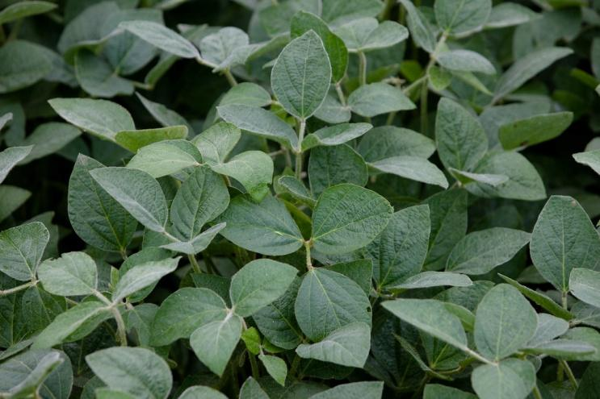

***Chapter 2 .Literature Review***

# *Literature Review*

**

Agriculture is the primary sector of food providence in India, and it’s a growing entity progressively. Agriculture is one of the most important activities for developing countries, contributing to the production of food and raw material. In addition, agriculture provides employment opportunities for a large portion of a country population and represents a large part of the national income (FAO, 2017). Despite the importance and productivity growth in recent years, agriculture in 2050 will have to produce almost 50 percent more than it did in 2012 to meet the demand of the world population (FAO, 2017). To increase productivity, proper management of a crop, including pest control, is crucial. Annually, plant pests cause crop losses of 20 to 40 percent of production (FAO, 2017). The losses caused by invasive insects cost the global economy around US$70 billion annually (Bradshaw et al., 2016). The main consequence of invasive insects is the herbivory and injury that result in a functional reduction of the total leaf surface of the plant. Segmentation is a technique for distributing and classifying image into several parts of the area n, where, each area has similarity attributes but the result of attributes are not the same. The segmentation process is completed through k-means clustering technique. There various papers describing to detecting the diseases and methods suggesting the implementation ways as shown and consulted here.

* 1. ***Preliminary Investigation:****-*

**Anand H. Kulkarni et al.** designed a methodology for detecting plants diseases early and accurately. He used diverse image processing techniques, where Gabor filter was used for features extraction and Artificial Neural Network (ANN) based classifier was used for classification with achieving a recognition rate of about 91%[2].

**P. Revathi et al.** used homogeneous techniques such as sobel and canny filter to identify the leaf edges. Those extracted edge features were then used in classification to identify the disease spots. The proposed work is based on Image Edge detection Segmentation techniques in which, the captured images are processed for enrichment first. Then R, G, B color Feature image segmentation is carried out to get target regions (disease spots). Further, image features such as boundary, shape, color and texture are extracted for the disease spots to recognize diseases and control the pest recommendation. The three parts that constitute the research work are- the cotton leaf spot, cotton leaf color segmentation, Edge detection based Image segmentation, analysis and classification of disease. [3].

**Tushar H Jaware et al.** proposed a novel and improved k-means clustering technique to solve low-level image segmentation. The improved algorithm uses noise data filter and hence, the clustering results improved significantly. The impact of the noise data on K-means algorithm dropped effectively and the obtained clustering results were more accurate.[4].

**Al-Hiary et al. 2011** followed the approach as- first the digital images were obtained using the digital camera. Then image processing techniques, such as image enhancement, segmentation, color space conversion and filtering, were applied to make the images suitable for the next steps. Then, important features were extracted from the image and used as an input for the classifier[7].

The Convolutional Neural Network (CNN) – a neural network based on human visual system was first inspired by **Hubel and Wiesel 1962** and it is being currently applied to a large number of pattern recognition problems by the researchers.

**Di Cui et al.**, Study explains the image processing techniques for multispectral images to detect the rust on plant leaf and also about the frequency with which the disease would spread and grow in amount . He used the dataset which contained the images collected from a greenhouse of research institute. The explained method used the concept to evaluate centroid for each image for further processing[1].

**Sanjay B. Dhaygude et al.** used the Spatial gray-level dependence matrices (SGDM) method for extracting the statistical texture features. He followed the procedure as first, the RGB images of the leaf were obtained. The images were then converted into Hue Saturation Value (HSV) color space representation. After the transformation process, the Hue component was taken for further analysis. Then the further steps including segmentation were applied.[5]

**Dheeb Al Bashish, et al.** developed neural network classifier based on statistical classification and could successfully detect and classify the diseases with a precision of around 93%. The proposed methodology was based on image processing and comprised of four phases which are as follows- (a) create a color transformation structure for the RGB leaf image. (b) Images were segmented using K-means clustering (c) texture features for the segmented infected objects were calculated and (d) in the fourth phase, the extracted features were passed through a pre-trained neural network [6].

**Sharada P. Mohanty et al. (Mohanty, Hughes, and Salathe 2016)**, used the existing deep CNN architectures, i.e AlexNet (Krizhevsky, Sutskever, and Hinton 2012) and GoogLeNet (Szegedy et al. 2015) to classify plant diseases. They used a public dataset of 54,306 images of diseased and healthy plant leaves that were collected under controlled conditions, the CNN was trained to identify 14 crop species and 26 diseases (or absence thereof). The models achieved 99.35% accuracy. When tested on a set of images taken at a different environment than the images used for the training, however, the model’s accuracy dropped to 31.4%. Overall the result demonstrates the feasibility of deep CNN for plant disease classification[14].

1. Naik and Sivappagari [8] have presented the plant leaf
2. disease detection by incorporating the concepts of genetic
3. algorithm, neural network and support vector machine. Here,
4. support vector machine is used for the detection and
5. classification of leaf diseases. Genetic algorithm has been
6. used for the image segmentation.
7. Naik and Sivappagari [8] have presented the plant leaf
8. disease detection by incorporating the concepts of genetic
9. algorithm, neural network and support vector machine. Here,
10. support vector machine is used for the detection and
11. classification of leaf diseases. Genetic algorithm has been
12. used for the image segmentation.
13. Naik and Sivappagari [8] have presented the plant leaf
14. disease detection by incorporating the concepts of genetic
15. algorithm, neural network and support vector machine. Here,
16. support vector machine is used for the detection and
17. classification of leaf diseases. Genetic algorithm has been
18. used for the image segmentation.
19. Naik and Sivappagari [8] have presented the plant leaf
20. disease detection by incorporating the concepts of genetic
21. algorithm, neural network and support vector machine. Here,
22. support vector machine is used for the detection and
23. classification of leaf diseases. Genetic algorithm has been
24. used for the image segmentation.

**Naik and Sivappagari** presented the plant disease identification detection by incorporating the concepts of genetic algorithm, neural networks and support vector machine. They used SVM for the detection and classification of leaf diseases and the genetic algorithm for image segmentation[16].

**Dandawate and Kokare** used the Support Vector Machine (SVM) concept for the detection and classification of plants as healthy or infected by diseases. They implemented the SIFT approach that could automatically recognize the plant species by their leaf shape. This system had an accuracy of about 93.79%.

Neural Network was used to observe the results. MATLAB was used as an experimental software.

***Chapter 3 .Proposed Work***

# *Proposed Work*

**

***Overview:-***

The key diseases of plants/crop leaf are viral, fungus and bacterial disease similar Alternaria, Anthracnose, bacterial spot, canker, etc. The viral disease is happened by green changes, fungus disease is happened by the attendance of fungus in the leaf and bacterial disease is due to presence of origins in leaf.

Segmentation technique is done by K-means clustering algorithm. The Red Green Blue color space is converted into the Lab color space. The disease is detected in the form of L*a*b color space. The Lab color model is composed of three elements: such as L shows luminosity layer and a*b shows chromaticity layer. It’s important to detect diseases on wheat leaf appropriately. When they are infected by diseases, there is change occurred in the shape, size and color. These suggestions can be patterned mechanically but not in appropriate amount. The stages include in performing the proposed model is as follows:-

***3.1 The Proposal:-***

**A. Image Acquisition**:- The real time images are fed directly from the camera. For further analysis, proper visibility and easy analysis of images, white background is created because most of leaves colour varies from red to green for exact segmentation.

**B. Image Preprocessing**:- Image preprocessing is required to resize captured image from high resolution to low resolution. The image resizing can be done through the process of interpolation. Captured input image is being converted into a grayscale image using colour conversion by the equation Image = 0.3R + 0.59G + 0.11B The captured image placed in white background results in large differences between grey values of object and background. References [1] have discussed the application of computer vision technique to enhance the plant leave in order to detect diseases. Computer vision image enhancement (Colour conversion and Histogram equalization) can be detecting highly enhanced images with higher clarity than captured images. Captured infected plant leaves images can be diagnose using Grayscale translation and histogram equalization.

**C. Disease Segmentation**:- Disease Segmentation is an important step to make something that is more meaningful and easier to analyze. The goal of segmentation is to simplify or change the representation of an image into multiple segments for further analysis .

**D. Feature Extraction Feature:-**Extraction is one of the most interesting steps of image processing to reduce the efficient part of an image or dimensionally reduction of interesting parts of an image as a compact feature vector. Feature reduction representation is useful when the image size is large and required to rapidly complete the tasks such as image matching and retrieval. Other common feature extraction techniques include: Histogram of oriented gradients (HOG) Speeded-up robust features (SURF) Local binary patterns (LBP) Haar wavelets Colour histograms. Once the features have been extracted, they may be used to build machine learning models for accurate object recognition or object detection. applies feature extraction to recognise leaf for plant classification using GLCM and PCA methods. Different features are needed to describe the different properties of the leaves. For feature extraction of leaves recognition, gray-level co-occurrence matrix method is introduced. Gray-level co-occurrence matrix (GLSM matrices) is designed to measure the spatial relationships between pixels.

***3.2 Benefits of the proposed system:-***

The proposed system benefits mainly in terms of accuracy in the detection of diseases, the model trained during the course of developing the project has the following benefits with it:

(i) More accurate

(ii) Feasible

(iii) Of practical implementation and utility

(iv) Less investment and capital is required

***3.3 Block Diagram:-***

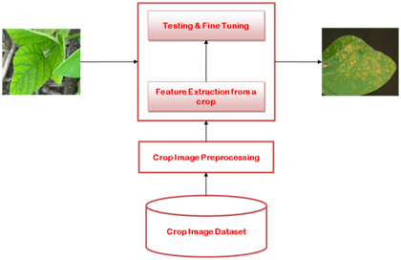

**The architecture of Crop Disease Detection System**

***3.4 Deployment Requirements:-***

***Software:***

The project is deployed on a cloud interface ‘Google Colab’. Colab is preferred over the python editors due to the following reasons:

[1] The code can be combined into a single unit with ease.

[2] The external CPU utilization is less.

[3] Online platform offers the required virtual memory space, which in turn does not affect the working of the system.

[4] Google Colaboratory is a cloud service that can be used for free of cost, provided by Google.

[5] It supports free GPU and is based on Google Jupyter Notebooks environment.

[6] It provides a platform for anyone to develop deep learning applications using commonly used libraries such as PyTorch, TensorFlow and Keras.

[7] It provides a way for your machine to not carry the load of heavy workout of your ML operations.

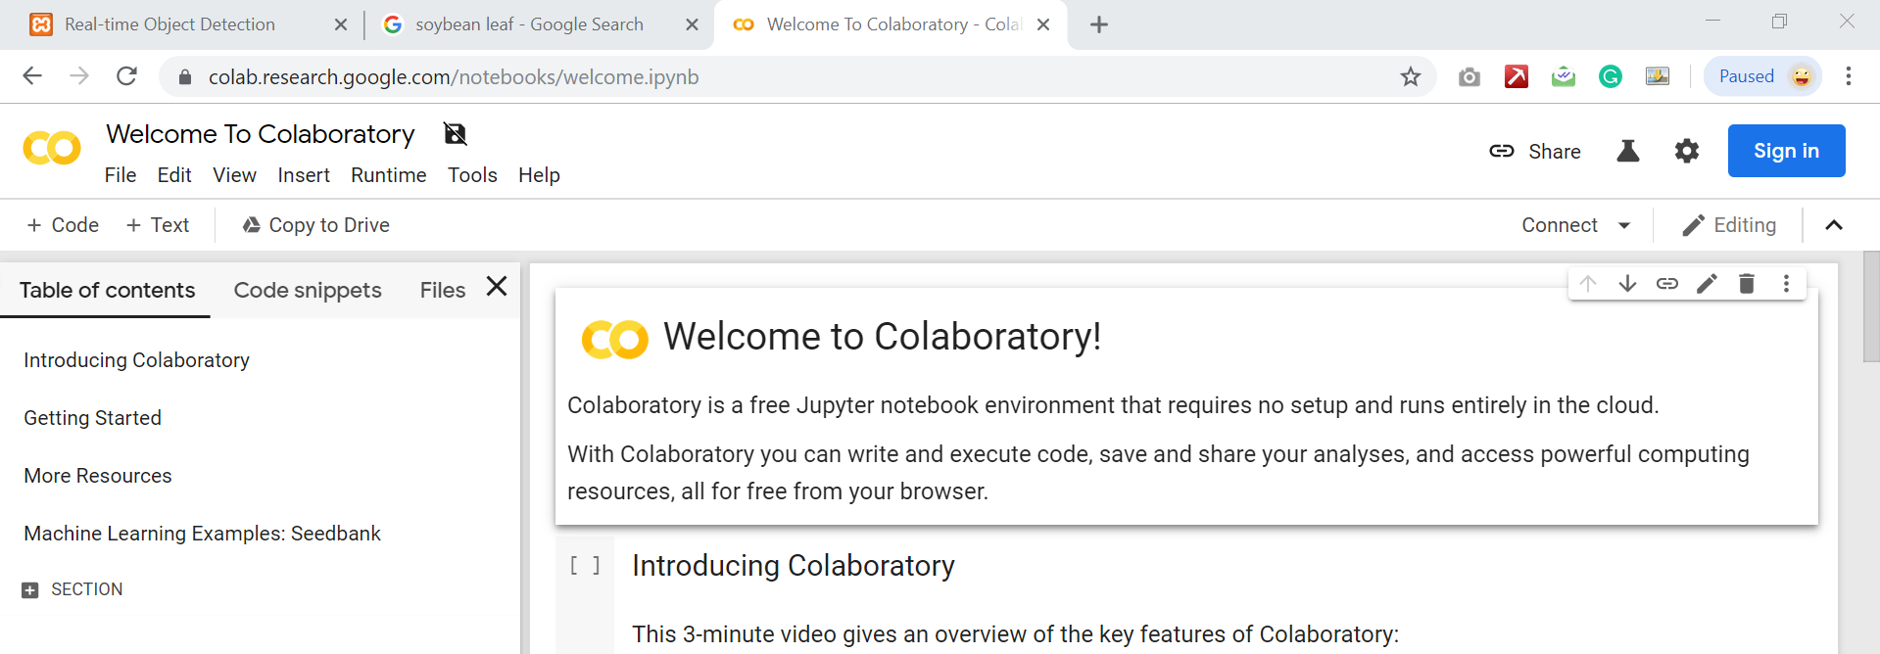

***Chapter 4 .Implementation***

# *Implementation*

**

***4.1 Techniques Used:-***

***Deep Learning***

Deep learning is an artificial intelligence function that imitates the workings of the human brain in processing data and creating patterns for use in decision making. Deep learning is a subset of machine learning in artificial intelligence (AI) that has networks capable of learning unsupervised from data that is unstructured or unlabeled. Also known as deep neural learning or deep neural network.Deep Learning is a subfield of machine learning concerned with algorithms inspired by the structure and function of the brain called artificial neural networks.

### *How Deep Learning Works*

Deep learning has evolved hand-in-hand with the digital era, which has brought about an explosion of data in all forms and from every region of the world. This data, known simply as big data, is drawn from sources like social media, internet search engines, e-commerce platforms, and online cinemas, among others. This enormous amount of data is readily accessible and can be shared through fintech applications like cloud computing.

However, the data, which normally is unstructured, is so vast that it could take decades for humans to comprehend it and extract relevant information. Companies realize the incredible potential that can result from unraveling this wealth of information and are increasingly adapting to AI systems for automated support.

***Convolutional Neural Network***

In deep learning, a convolutional neural network (CNN, or ConvNet) is a class of deep neural networks, most commonly applied to analyzing visual imagery.

They are also known as shift invariant or space invariant artificial neural networks (SIANN), based on their shared-weights architecture and translation invariance characteristics. They have applications in image and video recognition, recommender systems, image classification, medical image analysis, and natural language processing. The name “convolutional neural network” indicates that the network employs a mathematical operation called convolution. Convolution is a specialized kind of linear operation. Convolutional networks are simply neural networks that use convolution in place of general matrix multiplication in at least one of their layers.

The convolutional neural network, or CNN for short, is a specialized type of neural network model designed for working with two-dimensional image data, although they can be used with one-dimensional and three-dimensional data.

Central to the convolutional neural network is the convolutional layer that gives the network its name. This layer performs an operation called a “convolution“.

In the context of a convolutional neural network, a convolution is a linear operation that involves the multiplication of a set of weights with the input, much like a traditional neural network. Given that the technique was designed for two-dimensional input, the multiplication is performed between an array of input data and a two-dimensional array of weights, called a filter or a kernel.

The filter is smaller than the input data and the type of multiplication applied between a filter-sized patch of the input and the filter is a dot product. A dot product is the element-wise multiplication between the filter-sized patch of the input and filter, which is then summed, always resulting in a single value. Because it results in a single value, the operation is often referred to as the “scalar product“.

Using a filter smaller than the input is intentional as it allows the same filter (set of weights) to be multiplied by the input array multiple times at different points on the input. Specifically, the filter is applied systematically to each overlapping part or filter-sized patch of the input data, left to right, top to bottom.

This systematic application of the same filter across an image is a powerful idea. If the filter is designed to detect a specific type of feature in the input, then the application of that filter systematically across the entire input image allows the filter an opportunity to discover that feature anywhere in the image. This capability is commonly referred to as translation invariance, e.g. the general interest in whether the feature is present rather than where it was present.

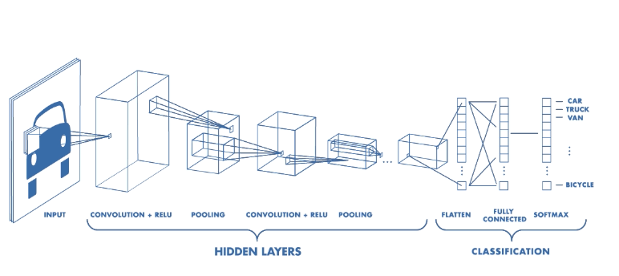

Feature extraction

Convolution is one of the main building blocks of a CNN. The term convolution refers to the mathematical combination of two functions to produce a third function. It merges two sets of information.

In the case of a CNN, the convolution is performed on the input data with the use of a filter or kernel (these terms are used interchangeably) to then produce a feature map.

We execute a convolution by sliding the filter over the input. At every location, a matrix multiplication is performed and sums the result onto the feature map.

In the animation below, you can see the convolution operation. You can see the filter (the green square) is sliding over our input (the blue square) and the sum of the convolution goes into the feature map (the red square).

The area of our filter is also called the receptive field, named after the neuron cells! The size of this filter is 3x3.



Left: the filter slides over the input. Right: the result is summed and added to the feature map.

Each image is namely represented as a 3D matrix with a [dimension for width, height, and depth](https://www.youtube.com/watch?v=jajksuQW4mc). Depth is a dimension because of the colours channels used in an image (RGB).

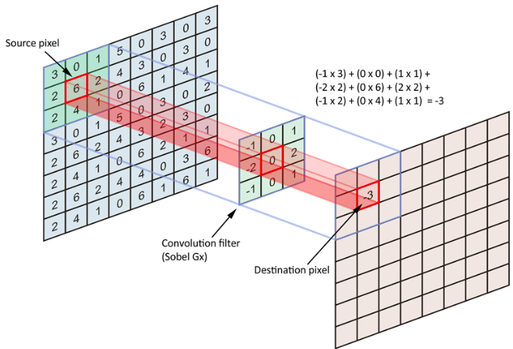

The filter slides over the input and performs its output on the new layer.

Just like any other Neural Network, we use an activation function to make our output non-linear. In the case of a Convolutional Neural Network, the output of the convolution will be passed through the activation function. This could be the ReLU activation function.

Stride is the size of the step the convolution filter moves each time. A stride size is usually 1, meaning the filter slides pixel by pixel. By increasing the stride size, your filter is sliding over the input with a larger interval and thus has less overlap between the cells.

The animation below shows stride size 1 in action.

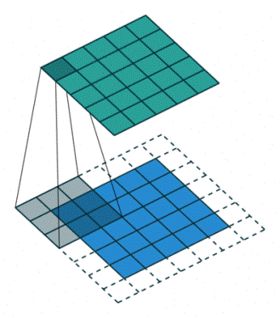

Because the size of the feature map is always smaller than the input, we have to do something to prevent our feature map from shrinking. This is where we use padding.

A layer of zero-value pixels is added to surround the input with zeros, so that our feature map will not shrink. In addition to keeping the spatial size constant after performing convolution, padding also improves performance and makes sure the kernel and stride size will fit in the input.

After a convolution layer, it is common to add a pooling layer in between CNN layers. The function of pooling is to continuously reduce the dimensionality to reduce the number of parameters and computation in the network. This shortens the training time and controls overfitting.

The most frequent type of pooling is max pooling, which takes the maximum value in each window. These window sizes need to be specified beforehand. This decreases the feature map size while at the same time keeping the significant information.

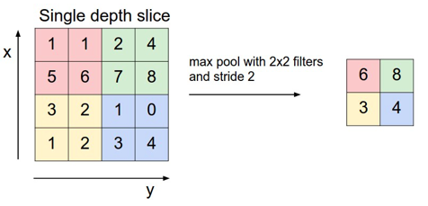

Max pooling takes the largest values.

Thus when using a CNN, the four important hyperparameters we have to decide on are:

* the kernel size
* the filter count (that is, how many filters do we want to use)
* stride (how big are the steps of the filter)
* padding

After the convolution and pooling layers, our classification part consists of a few fully connected layers. However, these fully connected layers can only accept 1 Dimensional data. To convert our 3D data to 1D, we use the function flatten in Python. This essentially arranges our 3D volume into a 1D vector.

The last layers of a Convolutional NN are fully connected layers. Neurons in a fully connected layer have full connections to all the activations in the previous layer. This part is in principle the same as a regular Neural Network.

***VGG Architecture***

VGG16 is a convolutional neural network model proposed by K. Simonyan and A. Zisserman from the University of Oxford in the paper “Very Deep Convolutional Networks for Large-Scale Image Recognition”. The model achieves 92.7% top-5 test accuracy in ImageNet, which is a dataset of over 14 million images belonging to 1000 classes. It was one of the famous model submitted to ILSVRC-2014. It makes the improvement over AlexNet by replacing large kernel-sized filters (11 and 5 in the first and second convolutional layer, respectively) with multiple 3×3 kernel-sized filters one after another. VGG16 was trained for weeks and was using NVIDIA Titan Black GPU’s.

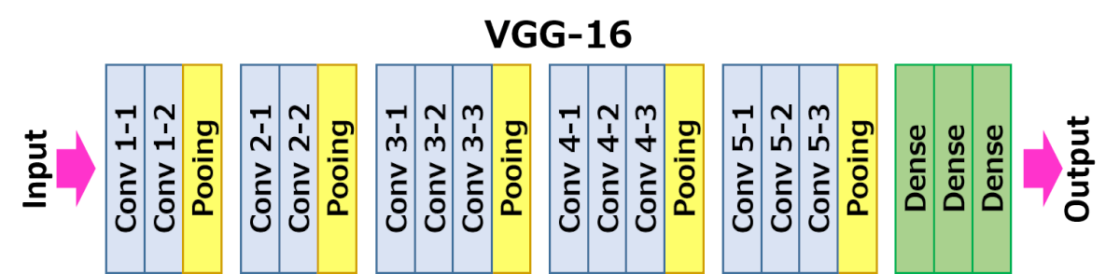

## **DataSet**

ImageNet is a dataset of over 15 million labeled high-resolution images belonging to roughly 22,000 categories. The images were collected from the web and labeled by human labelers using Amazon’s Mechanical Turk crowd-sourcing tool. Starting in 2010, as part of the Pascal Visual Object Challenge, an annual competition called the ImageNet Large-Scale Visual Recognition Challenge (ILSVRC) has been held. ILSVRC uses a subset of ImageNet with roughly 1000 images in each of 1000 categories. In all, there are roughly 1.2 million training images, 50,000 validation images, and 150,000 testing images. ImageNet consists of variable-resolution images. Therefore, the images have been down-sampled to a fixed resolution of 256×256. Given a rectangular image, the image is rescaled and cropped out the central 256×256 patch from the resulting image.

## The Architecture

The architecture depicted below is VGG16.

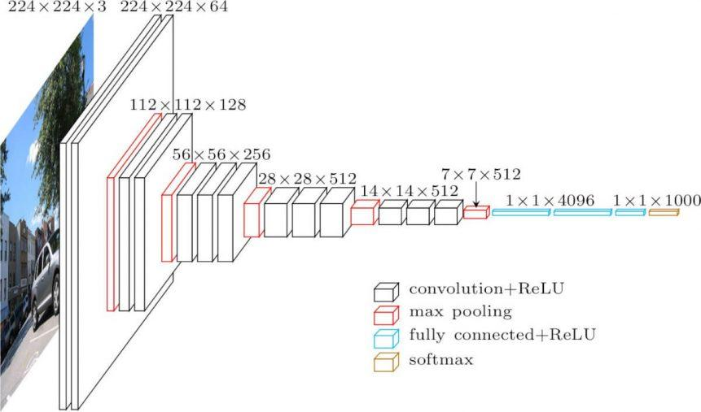

VGG16 Architecture

The input to cov1 layer is of fixed size 224 x 224 RGB image. The image is passed through a stack of convolutional (conv.) layers, where the filters were used with a very small receptive field: 3×3 (which is the smallest size to capture the notion of left/right, up/down, center). In one of the configurations, it also utilizes 1×1 convolution filters, which can be seen as a linear transformation of the input channels (followed by non-linearity). The convolution stride is fixed to 1 pixel; the spatial padding of conv. layer input is such that the spatial resolution is preserved after convolution, i.e. the padding is 1-pixel for 3×3 conv. layers. Spatial pooling is carried out by five max-pooling layers, which follow some of the conv.  layers (not all the conv. layers are followed by max-pooling). Max-pooling is performed over a 2×2 pixel window, with stride 2.

Three Fully-Connected (FC) layers follow a stack of convolutional layers (which has a different depth in different architectures): the first two have 4096 channels each, the third performs 1000-way ILSVRC classification and thus contains 1000 channels (one for each class). The final layer is the soft-max layer. The configuration of the fully connected layers is the same in all networks.

All hidden layers are equipped with the rectification (ReLU) non-linearity. It is also noted that none of the networks (except for one) contain Local Response Normalisation (LRN), such normalization does not improve the performance on the ILSVRC dataset, but leads to increased memory consumption and computation time.

## Result

VGG16 significantly outperforms the previous generation of models in the ILSVRC-2012 and ILSVRC-2013 competitions. The VGG16 result is also competing for the classification task winner (GoogLeNet with 6.7% error) and substantially outperforms the ILSVRC-2013 winning submission Clarifai, which achieved 11.2% with external training data and 11.7% without it. Concerning the single-net performance, VGG16 architecture achieves the best result (7.0% test error), outperforming a single GoogLeNet by 0.9%.

***4.2 Tools Used:-***

1. ***OpenCV:***

OpenCV is the leading open source library for computer vision, image processing and machine learning, and now features GPU acceleration for real-time operation.OpenCV is released under a BSD license and hence it’s free for both academic and commercial use. It has C++, C, Python and Java interfaces and supports Windows, Linux, Mac OS, iOS and Android. OpenCV was designed for computational efficiency and with a strong focus on real-time applications. Written in optimized C/C++, the library can take advantage of multi-core processing. Adopted all around the world, OpenCV has more than 47 thousand people of user community and estimated number of downloads exceeding 6 million. Usage ranges from interactive art, to mines inspection, stitching maps on the web or through advanced robotics.

**OpenCV Applications**

OpenCV is being used for a very wide range of applications which include:

Street view image stitching

Automated inspection and surveillance

Robot and driver-less car navigation and control

Medical image analysis

Video/image search and retrieval

Movies - 3D structure from motion

Interactive art installations

***OpenCV Functionality***

Image/video I/O, processing, display (core, imgproc, highgui)

Object/feature detection (objdetect, features2d, nonfree)

Geometry-based monocular or stereo computer vision (calib3d, stitching, videostab)

Computational photography (photo, video, superres)

Machine learning & clustering (ml, flann)

CUDA  acceleration (gpu)

***4.3 Language Used:-***

The model implementation and code is written in Python language. The built in packages and libraries are imported and the functions are used.

Python along with Machine Learning and Deep Learning is used to build and train the CNN Model as the implementation part.

***4.4 Screenshots:-***

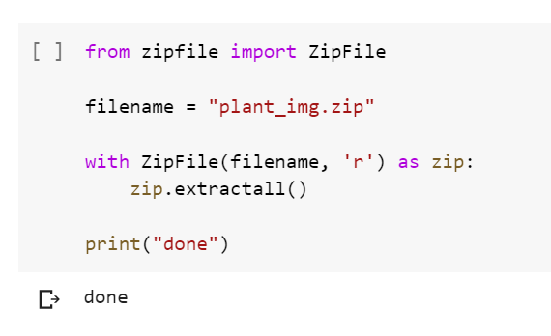

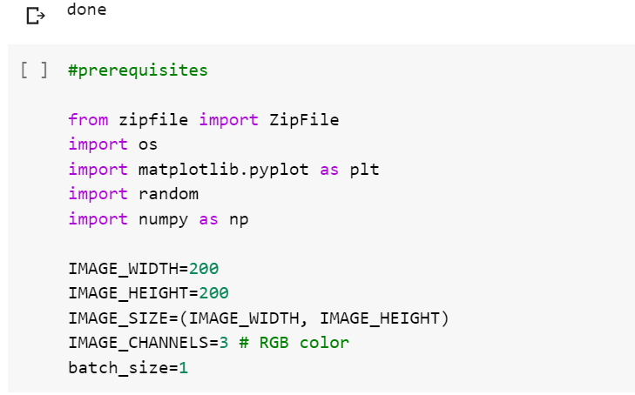

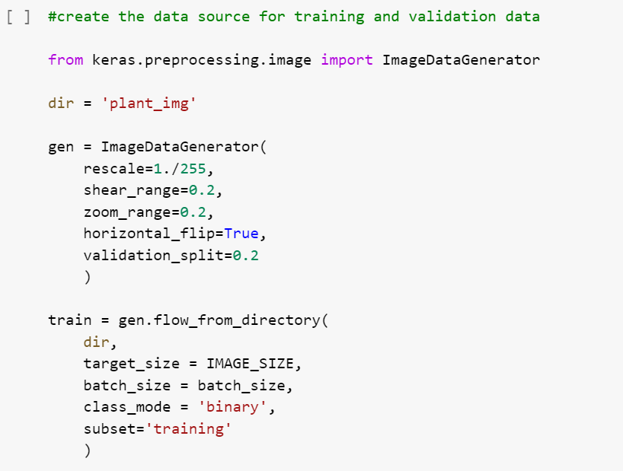

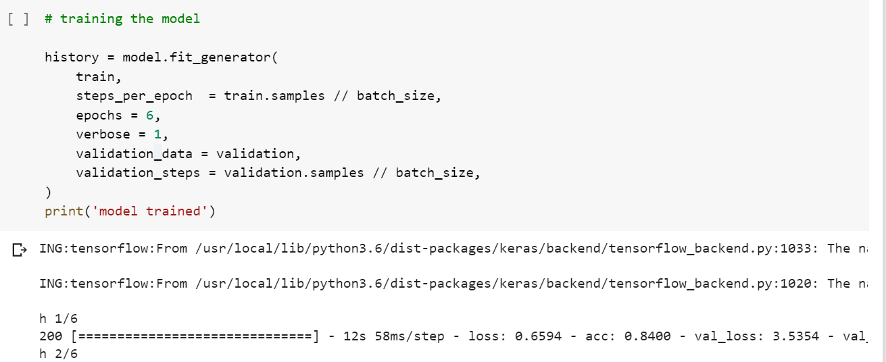

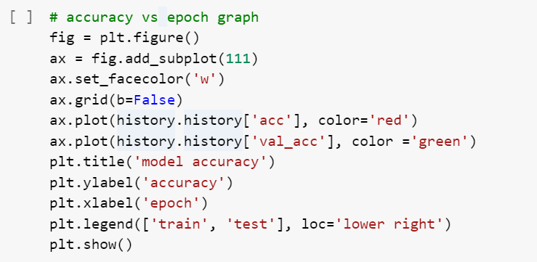

***Chapter 5 .Conclusion***

# *Conclusion*

**

***5.1 Conclusion:-***

This study report summarizes major image processing used for identification of leaf diseases are k-means clustering, SVM. This approach can significantly support an accurate detection of leaf disease. There are five steps for the leaf disease identification which are said to be image acquisition, image pre-processing, segmentation, feature extraction, classification. By computing amount of disease present in the leaf, we can use sufficient amount of pesticides to effectively control the pests in turn the crop yield will be increased. We can extend this approach by using different algorithms for segmentation, classification. By using this concept the disease identification is done for all kinds of leafs and also the user can know the affected area of leaf in percentage by identifying the disease properly the user can rectify the problem very easy and with less cost.

Data mining technologies has been incorporated in the agriculture industry. This project implements an innovative idea to identify the affected crops and provide remedy measures to the agricultural industry. By the use of k-mean clustering algorithm, the infected region of the leaf is segmented and analyzed. The images are fed to our application for the identification of diseases. It provides a good choice for agriculture community particularly in remote villages. It acts as an efficient system in terms of reducing clustering time and the area of infected region. Feature extraction technique helps to extract the infected leaf and also to classify the plant diseases.

***5.2 Limitations of the Work:-***

Every model that is developed and built comes with its own advantages and limitations. The proposed model limits on the following notes:

* The current built model detects whether a leaf is infected or not. It isn’t specific in predicting the disease by which the leaf has been infected.
* The CNN model takes a longer time to be trained.
* Since, the project is deployed on Google Colab, in case of inactivity for about an hour the dataset automatically gets erased off, and has to be uploaded all over again, which takes an additional amount of time.
* Unavailability of accurate dataset at present affects the accuracy and efficiency of the model.

***5.3 Suggestions and Recommendation for Future Work:-***

The project report provides a new insight in detection of the diseases of plant . The scope in doing research in this field is as follows:

1.There are two main characteristics of plantdisease detection using machine-learning methods that must be achieved, they are: speed and accuracy. Hence there is a scope for working on development of innovative, efficient & fast interpreting algorithms which will help plant scientist in detecting disease.

2. Work can be done for automatically estimating the severity of the detected disease.

3. Work proposed by researcher Yao can be extended for development of hybrid algorithms such as genetic algorithms & neural networks in order to increase the recognition rate of the final classification process.

To improve recognition rate in classification process Artificial Neural Network, Bayes classifier, Fuzzy Logic and hybrid algorithms can also be used.